EXPERIMENT-5
Name: Harshavarthini A Roll No: 240701181
Consider task analysis for an app and document user flows. Create corresponding wireframes using Lucidchart
1. Task Analysis
Task analysis is a technique used to divide a user's goal into smaller tasks to comprehend how a user interacts with an application. This technique is helpful to designers to study how users interact with an application or how they can improve it to enhance usability.
Task analysis includes:
Understanding user goals
Identifying tasks performed by users
Observing tasks performed by users
Improving user experience
For example, if a food ordering application is developed for a cloud kitchen, then a user's task is to order food. This task can be divided into various tasks, such as opening an application, browsing items, selecting items, adding items to a cart, making payments, etc.
2. User Flow
User flow is a description of how a user can interact with a particular application to achieve a specific goal. The user flow is a visual representation of how a user can navigate from one screen to another. The user flow is normally represented by a flowchart, which is created by connecting different screens or actions using an arrow to represent the process. The user flow is significant to designers because it allows them to:
Understand the navigation
Understand decision points
Eliminate unnecessary steps
Improve user experience
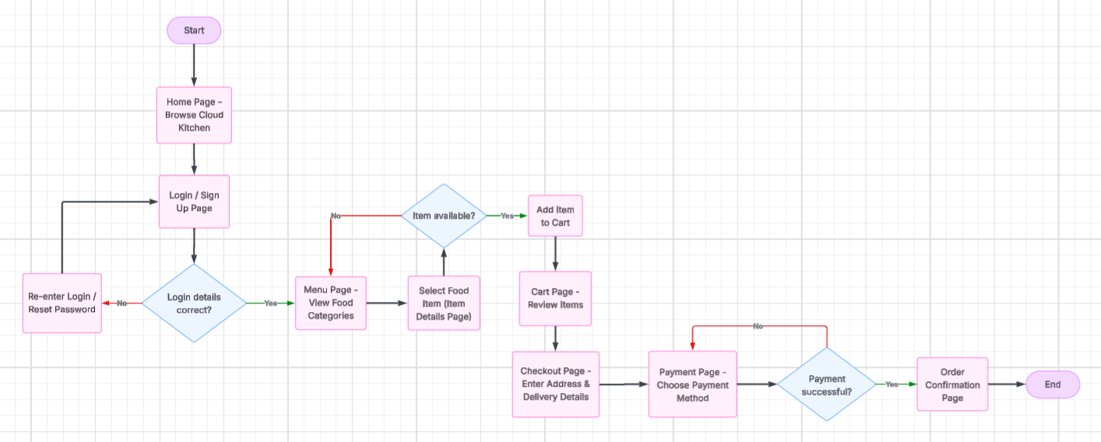
Page Wise Wireframe Description
1. Splash Screen
The splash screen is the screen that appears when the user launches the application. The screen displays the application’s name and Login button. This screen is useful in branding and loads the application’s resources before the user enters the application’s interface. The screen changes automatically after a few seconds and displays the Login/Signup screen.
Elements in the Wireframe:
App name
Login button
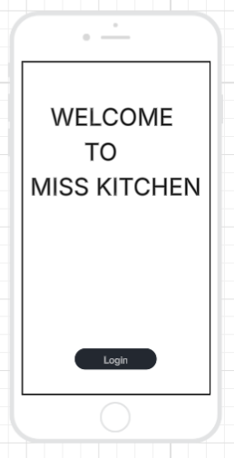
2. Login / Sign Up Page
The login or signup page is where users can log in to their existing account or create a new account. Users can log in to their existing account by providing their email along with their password. Users can choose the Sign Up option to create a new account in the application.
Elements in the wireframe:
Email Input Field
Password Input Field
Confirm Button
Forgot Password Option
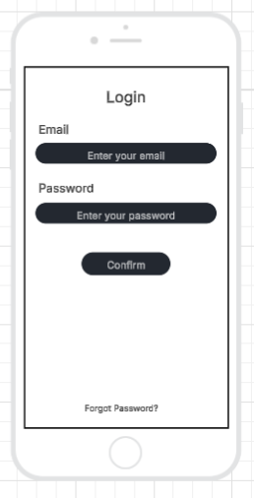
3. Menu Page
The menu page will display a list of food items available in the cloud kitchen. Users can scroll through the menu and choose their desired food items to order.
Elements of the wireframe:
List of food items
Images of food
Item prices and names
Add to cart button

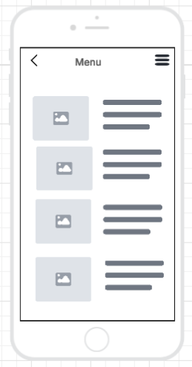
4. Item Details Page
This page displays the entire information about the selected food item. Users can view the description, price, and ingredients of the selected item before adding it to their cart.
Elements of the Wireframe:
Food Image
Food Name
Price
Description
Quantity Selector
Add to Cart Button

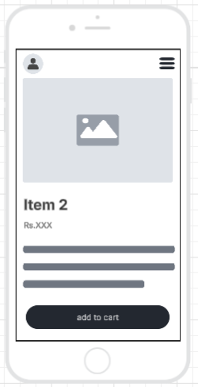
5. Cart Page
The cart page displays all the items the user has selected for purchase. The user has the option to add or remove items before checking out.
Elements of the Wireframe:
List of Selected Items
Quantity Control of Each Item
Total Price of the Items
Option to Remove an Item
Option to Proceed to Check Out

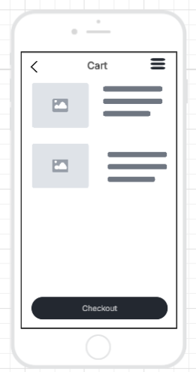
6. Checkout Page
This is a page where a customer can enter their delivery address and view a summary of their order before making payment.
Elements in the wireframe:
Delivery address field
Contact number
Order summary
Continue to Payment button
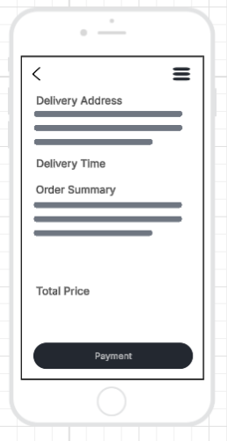
7. Payment Page
The payment page will allow the user to select the payment option and proceed with the payment. After the payment is made, the order will be confirmed.
The elements that will be used are:
The payment options (UPI, Credit/Debit Card, Cash On Delivery)
The payment details
Confirm Payment
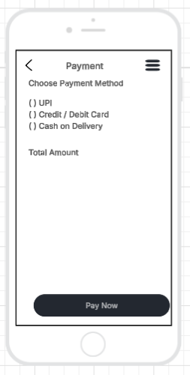
8. Order Confirmation Page
The order confirmation page is displayed after the payment process is successfully completed. The page displays the order confirmation.
Elements of the Wireframe:
Order confirmation message
Order ID
Estimated delivery time
Order details
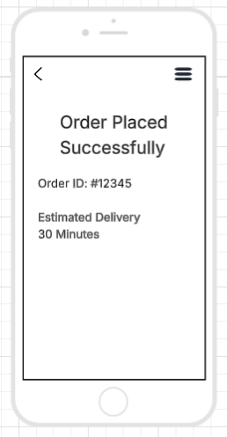
Prototype link:
Flow link: https://lucid.app/lucidchart/5aadcb7d-5103-45a9-aea4-f9acd7f8fcfc/edit?viewport_loc=-345%2C131%2C3024%2C1329%2C0_0&invitationId=inv_002ac3ad-b55e-413d-a076-670ca1d19397
Wireframe link: https://lucid.app/lucidchart/c820cbfd-e92f-4d6f-973e-ee565f9eeef6/edit?viewport_loc=-1005%2C-1604%2C3141%2C1380%2C0_0&invitationId=inv_c16902e7-1129-4074-8f46-b61956943b62

